**POSITIONING**

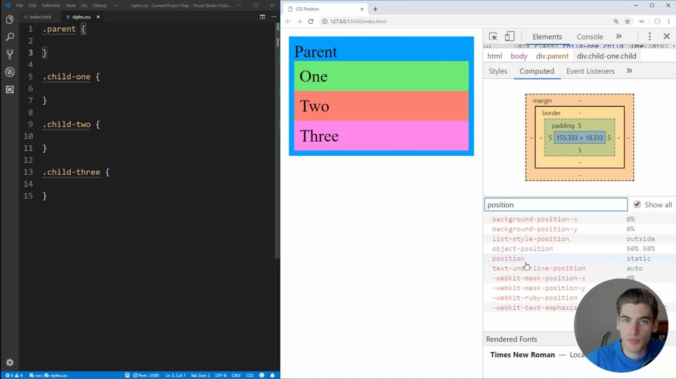To see specific CSS properties of element (from Dev Tools):

HTML elements are positioned static by default. Once you set the position (not static) property of the element, you can move the element around by setting a 'top', 'right', 'left', or 'bottom' properties.

1. Static: always positioned according to the normal flow of the page(default).
2. Relative: positioned relative to its normal position.
3. Fixed: positioned relative to the viewport, which means it always stays in the same place even if the page is scrolled.
4. Absolute: positioned relative to the nearest ancestor.
5. Sticky: positioned between relative and fixed, it’ll being relative until meet end of viewport then it’ll be fixed. Berada di posisi antara relatif dan fixed, akan berposisi relative sampai mentok layar, setelah mentok layar akan berposisi fixed.

**Note:**

‘position: absolute’ allows you to position something at an exact point on the screen without disturbing the other elements around it(in other words: don’t affect other elements and are also not affected by other elements). (because it’ll remove that element from the normal document flow while being positioned relative to an ancestor element).

A couple good use cases for absolute positioning are:

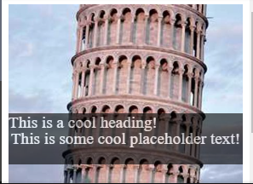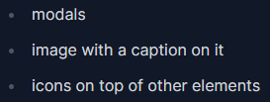

Disclaimer: absolute positioning has very specific use cases and if possible, using flexbox or grid should be prioritized. Absolute positioning shouldn’t be used to do entire page layouts.